
Kelly Walter，副教授，博士，主要从事马的饲养生产及营养与繁殖的研究。发表论文18篇。
主讲课程：动物繁殖学。
代表性论文：
- Walter, K., J. Altman, and K. Haussler. 2022. Reducing chronic back pain and inflammation in horses using a commercial herbal liniment. Equine Veterinary Education 35.
- Walter, K., J. Coverdale, T. A. Wickersham, J. Lucia, and C. Hammer. 2013. Influence of maternal plane of nutrition on mares and their foals: Determination of mare performance and voluntary dry matter intake during late pregnancy using a dual-marker system. Journal of Animal Science 91.
- Walter, K., and L. M. White. 2013. Increasing education and awareness of the unwanted horse issue affects student opinion of horse slaughter. Journal of Equine Veterinary Science 33:377.
- Hammer, C., K. Walter, J. Lucia, and J. Coverdale. 2011. Effect of Dietary Energy Manipulation on Mares and their Foals: Colostrum and IgG. Journal of Equine Veterinary Science - J EQUINE VET SCI 31:308-309.
- Walter, K., J. Coverdale, T. A. Wickersham, and J. Shelton. 2011. Influence of dietary methionine concentration on growth and nitrogen balance in weanling Quarter Horses. Journal of Animal Science 89:2132-8.
- Walter, K., T. A. Wickersham, C. Hammer, and J. Coverdale. 2011. Effect of Dietary Energy Manipulation on Mares and their Foals: Determination of Voluntary Dry Matter Intake of Mares During Late Pregnancy Using a Dual Marker System. Journal of Equine Veterinary Science - J EQUINE VET SCI 31:265-265.
- Walter, K., J. Coverdale, T. A. Wickersham, and J. Shelton. 2009. Influence of Total Sulfur Amino Acids on Growth and Nitrogen Retention of Weanling Horses. Journal of Equine Veterinary Science - J EQUINE VET SCI 29:349-350.


Emily Costello，生物学学士。
主讲课程：马科学导论。


Elizabeth Walker，副教授，博士，主要从事牲畜营养，可持续农业等研究，发表论文10余篇。
主讲课程：牛生产学。


Anower Jabed，分子生物学博士，主要研究分子生物学，擅长基因组测序和生物信息学分析，发表论文20余篇，参编书1部。
执教课程：牲畜管理、动物福利、动物保健。
代表性论文：
- Lloyd, Jordan T., Andrew G. Yee, Prasanna K. Kalligappa, Anower Jabed, Pang Y. Cheung, Kathryn L. Todd, Rashika N. Karunasinghe, Srdjan M. Vlajkovic, Peter S. Freestone, and Janusz Lipski (2022). Dopamine Dysregulation and Altered Responses to Drugs Affecting Dopaminergic Transmission in a New Dopamine Transporter Knockout (DAT-KO) Rat Model. Neuroscience, 491: 43-64.
- Khanh B Tran, Sharada Kolekar, Anower Jabed, Patrick Jaynes, Jen-Hsing Shih, Qian Wang, Jack U Flanagan; Gordon W Rewcastle, Bruce C Baguley, Peter R Shepherd. (2021). Diverse mechanisms activate the PI3K/mTOR pathway in melanomas: Implications for the use of PI 3-kinase inhibitors to overcome resistance to inhibitors of BRAF and MEK. BMC Cancer. 21(1):136.
- Khanh B. Tran, Gregory Gimenez, Peter Tsai, Sharada Kolekar, Euan J. Rodger, Aniruddha Chatterjee, Anower Jabed, Jen-Hsing Shih, Wayne R. Joseph, Elaine S. Marshall, Qian Wang, Cristin G. Print, Michael R. Eccles, Bruce C. Baguley, Peter R. Shepherd. (2020). Genomic and signalling pathway characterisation of the NZM panel of melanoma cell lines: a valuable model for studying the impact of genetic diversity in melanoma. Pigment Cell & Melanoma Research.34(1):136-143
- Vaidyanathan V, Naidu V, Karunasinghe N, Kao CHJ, Pallati R, Jabed A, Marlow G, Kallingappa P, Ferguson LR. (2017). Effect of ageing and single nucleotide polymorphisms associated with the risk of aggressive prostate cancer in a New Zealand population. Molecular BioSystems. 13(10):1967-1980
- Vaidyanathan V, Naidu V, Karunasinghe N, Jabed A, Pallavi R, Marlow G, Ferguson L. (2017). SNP-SNP interactions as risk factors for aggressive prostate cancer. F1000Research, 6:621.
- Vaidyanathan V, Naidu V, Kao CH, Karunasinghe N, Bishop KS, Wang A, Pallati R, Shepherd P, Masters J, Zhu S, Goudie M, Krishnan M, Jabed A, Marlow G, Narayanan A, Ferguson LR. (2017). Environmental factors and risk of aggressive prostate cancer among a population of New Zealand men: A genotypic approach. Molecular BioSystems, 13(4), 681-698.

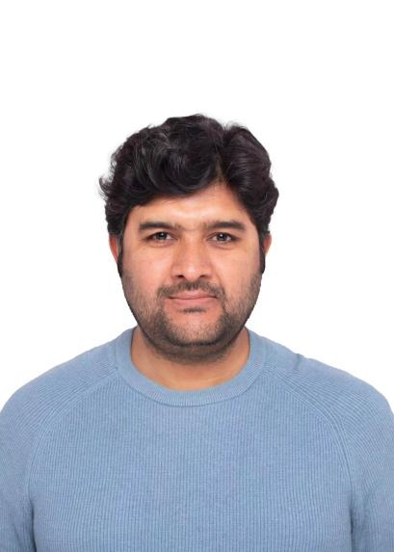

Syed Muhammad Sadiq Shah，生物化学与分子生物学博士，主要从事作物基因工程的研究，发表论文4篇。
执教课程：生物学导论、动物改良遗传学。
代表性论文：
- Shah, S. , Ullah, F. and Shah, S. (2019) Fatty Acid Profiling of Polyethylene Glycol Adapted and UnAdapted Cell Lines of Oryza sativa L.cv. Swat-1 under Temperature Stress. American Journal of Molecular Biology, 9, 145-153.
- Qing-guo, D. U., Juan, Y. A. N. G., Shah, S. M. S., Rong-xin, Y. A. N. G., Jing-juan, Y. U., & Wen-Xue, L. I. Comparative transcriptome analysis of the different nitrogen responses in low nitrogen-sensitive and -tolerant maize genotypes. Journal of Integrative Agriculture, 0. doi: 10.1016/S2095-3119(20)63220-8
- Shah, S. M. S., Ullah, F., & Munir, I.. (2021). Biochemical characterization for determination of genetic distances among different indigenous chickpea (Cicer arietinum L.) varieties of North-West Pakistan. Brazilian Journal of Biology, 81(4), 977-988.
- Shah SMS, Ullah F. A comprehensive overview of miRNA targeting drought stress resistance in plants. Brazilian Journal of Biology. 2021;83:e242708.

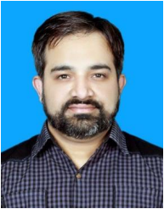
Ahsan Mustafa，动物营养与饲料科学博士，主要从事家禽营养领域研究。发表论文10余篇。
讲授课程：动物生理学、动物行为学、猪管理学。
代表性论文：
- Mustafa, A., Bai, S., Zeng, Q., Ding, X., Wang, J., Xuan, Y., Su, Z. and Zhang, K., (2021). Effect of organic acids on growth performance, intestinal morphology, and immunity of broiler chickens with and without coccidial challenge. AMB Express, 11(1), pp.1-18.
- Mustafa, A., Bai, S., Zeng, Q., Ding, X., Wang, J., Xuan, Y., Su, Z. and Zhang, K., (2021). Limitation and Potential Effects of Different Levels of Aging Corn on Performance, Antioxidative Capacity, Intestinal Health, and Microbiota in Broiler Chickens. Animals, 11, 2832.
- Mustafa, G.R., Zhao, K., He, X., Chen, S., Liu, S., Mustafa, A., He, L., Yang, Y., Yu, X., Penttinen, P. and Ao, X., (2021). Heavy metal resistance in Salmonella Typhimurium and its association with disinfectant and antibiotic resistance. Frontiers in microbiology, p.2120.

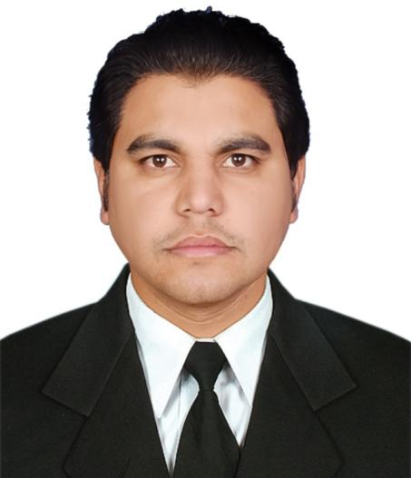
Farman Ullah ，助理教授，生物技术博士，主要从事动物生产和遗传学的相关研究。发表论文20余篇。
讲授课程：牛生产学、畜牧业原理。
代表性论文：
- Ullah, F., Jamal, S. M., Zhou, H., Hickford, Jon G (2022) Variation in ovine KRTAP8-2 and its association with wool characteristics in Pakistani sheep. Small Ruminant Research https://doi.org/10.1016/j.smallrumres.2021.106598
- Ullah, F., Jamal, S. M., Zhou, H., Hickford, Jon G (2021b) Association of KRTAP8-1 with wool characteristics of Pakistani sheep breeds and breed-crosses, Animal Biotechnology. https://doi.org/10.1080/10495398.2021.1990078
- Ullah, F., Khan, M. F. U., Khan, M. H., & Jamal, S. M. (2021a). Factors Affecting Mean Fiber Diameter in Selected Pakistani Sheep Breeds/Crosses. Journal of Natural Fibers, 18, 877-887.
- Ullah, F., Jamal, S. M., Zhou, H., Hickford, Jon G (2020b). Variation in the KRTAP6-3 gene and its association with wool characteristics in Pakistani sheep breeds and breedcrosses. Tropical Journal of Health and Production, 52, 3035–3043.https://doi.org/10.1007/s11250- 020-02322-6
- Ullah, F., Jamal, S. M., Ekegbu, U. J., Haruna, I. L., Zhou, H., Hickford, Jon G. (2020a). Polymorphism in the ovine keratin associated protein gene KRTAP7-1 and its association with wool characteristics. Journal of Animal Sciences. 98, 1: 1-7.
- Haruna, I. L., Ekegbu, U. J., Amirpour-Najafabadi H. Ullah F. Zhou, H., Hickford, Jon G (2020). Genetic Variations and Haplotypic Diversity in the Myostatin Gene of New Zealand Cattle Breeds. Gene 144400.
- Ullah, N., Hadi, F., Ullah, F., Ahmad, A., Ali, N., Jan, A.U. Analysis of heavy metals (Pb and Cd) in soil, peach fruit and its accumulation in human blood. (2017) International Journal of Agronomy and Agricultural Research 10 (4): 24-32.


Yunkyoung Lee，教授，博士，主要从事营养生物化学与代谢研究。主持中-韩政府间重点研发项目，推动成立“中-韩功能性植物多糖研发中心”，2023年获聘山东省双百计划高端专家。发表论文50余篇。
执教课程：动物营养学、学术写作。
代表性论文
- Chongyu Zhang, Eunyoung Kim, Jiamei Cui, Yunpeng Wang, Yunkyoung Lee*, Guiguo Zhang*. Influence of the ecological environment on the structural characteristics and bioactivities of polysaccharides from alfalfa (Medicago sativa L.). Food and Function. 2022,13, 7029-7045.
- Zemin Li, Chen Zhang, Shimin Zhang, Bo Li, Chong-Yu Zhang, Fawaz G Haj, Guiguo Zhang*, Yunkyoung Lee* The Intestinal Microbiota Characteristics of Salmonella-challenged Broilers and the Modulatory Effects of Alfalfa Polysaccharide on Intestinal Health. Scientific Reports. 2021,11:10910.
- Chen Zhang, Chongyu Zhang, Meiyu Du, Yunpeng Wang, Guiguo Zhang*, Yunkyoung Lee* Effects of dietary supplementation with different fermented feeds on performance, nutrient digestibility, and serum biochemical indexes of fattening lambs. Animal Bioscience. 2021.34.4:633-641.
- A-Reum Han, Jae-Hoon Kim, Eunyoung Kim, Jiamei Cui, In-suk Chai, Guiguo Zhang, Yunkyoung Lee* Hypotriglyceridemic effects of brown seaweed consumption via regulation of bile acid excretion and hepatic lipogenesis in high fat diet-induced obese mice. Nutrition Research and Practice. 2020, 14, 6, 580-592.
- Chen Zhang, Zemin Li, Chong-Yu Zhang, Mengmeng Li, Yunkyoung Lee, Guiguo Zhang* Extract Methods, Molecular Characteristics, and Bioactivities of Polysaccharide from Alfalfa (Medicago sativa L.) Nutrients. 2019,11 (5)1181-1196. Hyo-Seon Yang, Fawaz G Haj, Myoungsook Lee, Inhae Kang, Guiguo Zhang, Yunkyoung Lee*. Laminaria japonica Extract Enhances Intestinal Barrier Function by Altering Inflammatory Response and Tight Junction-Related Protein in Lipopolysaccharide-Stimulated Caco-2 Cells. Nutrients. 2019,11,1001
- Jiamei Cui, Eunyoung Kim, Guiguo Zhang, Yunkyoung Lee1*. Antioxidant and Immunomodulatory Effects of Laminaria japonica Water Extract. The Korean Society of Food Culture. 2022, 37(5):1-8.

